Programming Assignment Unit 2 (CS 1101 -01)
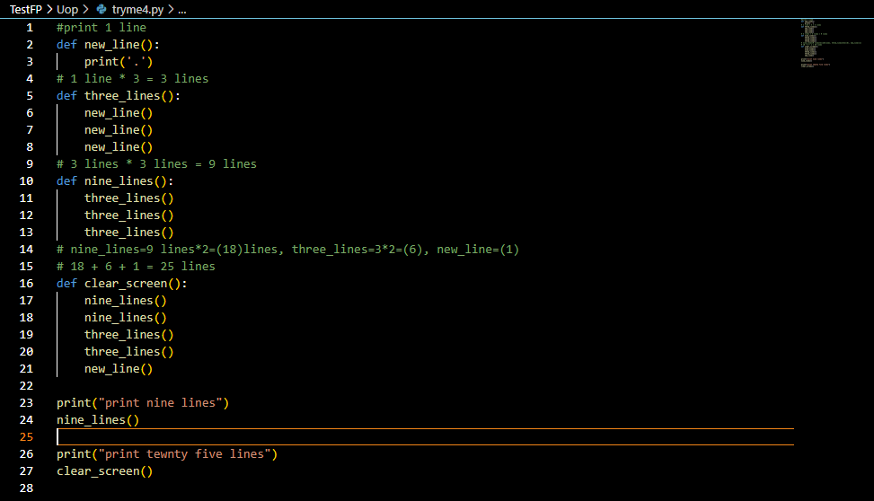

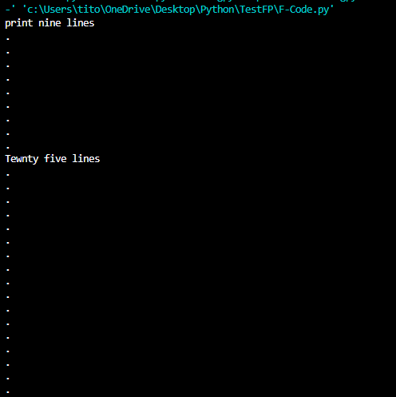
Output:

Reference:
pythonanywhere. (2022). Host, run, and code Python in the cloud. Anaconda. https://www.pythonanywhere.com/

